Il cooperative problem solving nella scuola secondaria di secondo grado: report di un’attività di formazione per docenti e studenti

Cooperative Problem Solving: An experience on the Training of High-School Teachers and Students
Carlo Maria Carbonaro¹, Alessia Zurru^{1,2,3}, Viviana Fanti^{1,2}, Matteo Tuveri², Gianluca Usai^{1,2}
¹Department of Physics, University of Cagliari, Monserrato, Italy
²INFN Sezione di Cagliari, Monserrato, Italy
³Laboratorio Scienza, Department of Physics, University of Cagliari, Monserrato, Italy
Riassunto
Il “cooperative problem-solving” (CPS) è un utile strumento per favorire l'apprendimento della fisica e lo sviluppo delle capacità di problem-solving negli studenti. In questo lavoro presenteremo i risultati di un'esperienza formativa basata sul CPS rivolta agli insegnanti di fisica e agli studenti delle classi quarte e quinta delle scuole secondarie di secondo grado. Dapprima illustreremo il metodo da noi utilizzato durante l’attività di formazione. In secondo luogo, mostreremo i risultati della sua applicazione con una classe di docenti e con una di studenti di quarta e quinta superiore. L’attività proposta è stata valutata come positiva, sottolineando l’importanza della cooperazione all'interno del gruppo e dell’utilizzo di uno schema risolutivo come utili strumenti per affrontare la risoluzione di problemi contestualizzati. L’analisi ex-post ha mostrato la necessità di implementare ulteriori strategie per il miglioramento delle capacità di problem-solving degli studenti.
Summary
We present the results of a training experience dispensed to Italian high school physics teachers to promote the application of the cooperative problem-solving method as a useful strategy to improve physics learning at high-school level and to foster the development of problem-solving skills. Beside analysing the method and discussing the ways to propose and apply it in a high school context, the teachers experienced the method acting both as learners and as tutors of student group learners. Students and teachers evaluated the experience as positive, mainly focusing on cooperation within the group by information exchange and the application of a solution scheme. The ex-post analysis of the students’ performances in applying the method to solve some rich-context text showed the need of improving their critical thinking attitude with respect to achieved results to fully exploit the strategy and develop their problem-solving skills.

1. Introduction
The promotion of courses aimed to promote the use of problem solving (PS) is gaining a lot of interest in the field of education. Indeed, PS is a strongly requested skill in the whole STEM courses and increasingly appreciated in professional and social world [1-7], being recognized as a habitus useful to manage new situations and contexts. PS can be in general defined as the ability of one person to cope with a problem, the latter being a new situation which requires elaborating previous knowledge and experience to achieve the solution [8-9]. Physicists always valued PS as one of the most peculiar features of their discipline and spent a lot of efforts to analyse how to teach it and how to use it for teaching physics [10-15]. Teaching PS strategies to students was demonstrated as very effective in improving their performances in PS and their ability, in general, to use structured strategies to deal with professional issues [16-18]. Among the numerous methods to teach PS, Pólya [19] espoused a four-step problem-solving process: 1. Understand the problem, 2. Make a plan, 3. Carry out the plan, and 4. Look back on your work. While Pólya did recommend some reflection at the end to help the solver understand what worked and what did not, his suggested procedure does not emphasize the necessary monitoring that must occur throughout the process in order to successfully solve a problem. Bransford and Stein developed the “ideal” method of PS, which includes the step “Explore Alternative Approaches” [20]. While this does encourage students to do some monitoring, it does not strongly encourage different ways of monitoring throughout the solution process. There are other models of PS that include monitoring and other components such as confidence and creativity, but these are likely too complex for teachers and students to use as a tool in the classroom. Heller proposed to implement the Pólya’s solving strategy in cooperative grouping by focusing on cooperation as a key feature in the learning process. Cooperative learning was indeed proven successful at high school and college level in improving students’ achievements and teaching approach [21-23]. This is also confirmed by cognitive studies in the field, showing that sharing different points of view to solve a common problem involves cognitive development and a more effective learning [24].
Cooperative learning and PS methodologies are certainly realized in the so-called Cooperative Problem Solving (CPS) method. The CPS is a social interaction of multiple entities working together (in group) to achieve a common goal. It is based on the pedagogical model developed at the School of Physics and Astronomy - University of Minnesota [12-13] and on the model of Peer Instruction developed at Harvard [25]. The application of the CPS in physics involves the use of a shared framework for the solution of complex problems with a rich context. The use of such a framework accomplishes the target of stimulating the interaction of a group to achieve a common goal and can be useful for both students and teachers (novices and experts, respectively) to deal with the categories and the representation of a physics problem [26].
The CPS method proposed in [12-13] is based on 5 iterative steps: focus the problem; description of the problem; plan of a solution; execution of the plan; evaluation of the solution. Its implementation passes through the formation of cooperative groups with an optimal number of components of three. Every member of the group has a specific pre-assigned role with specific tasks: mentor (responsible for coordination of members and managing of their activities), secretary (responsible for validation and verification of adopted procedures), sceptic (responsible for critical checking of all the possible solving strategies and the evaluation of group’s proposals). In the CPS method, teacher assumes the role of tutor or coach with the aim to guide students in applying the method, in solving problems during the whole learning process. By means of CPS method, group members can improve their capabilities in solving complex problems and experience interaction and confrontation among peers. The method also helps in developing both individual and group consciousness and related responsibilities.
Inspired by Heller’s proposal of CPS strategy, in this paper we report the results of a training experience dispensed to Italian high school physics teachers to promote the application of the CPS method as a useful strategy to improve physics learning at high school level and to foster the development of problem-solving skills. We also experimented the approach with a group of teachers and one of students to evaluate their willingness towards the method.

2. Methods
The research has been conducted between December 2017 and January 2018 at the Physics Department of University of Cagliari (Italy) as part of local activities of the Piano Lauree Scientifiche project [27], with a sample of teachers and students coming from scientific and classical high schools of the metropolitan area of Cagliari. We firstly organized a four-day course for teachers where the approach was explained and tested. Beside receiving the instruction to the method (12 hours), teachers were also involved in direct CPS experience. Divided in 3-member groups, they discussed motivations and ways to apply CPS in high school classes and evaluated different aspects of the distinction in roles within the group. They also participated to six hours of exercitation to product and examine enriched problems of physics achieving a common and shared database of problems.
Finally, the approach was tested with two mixed large classes of high school students, teachers being involved as active coaches or as passive scouts (4 hours). Students faced up with the solution of physics text-enriched problems (see Supplementary Files) based on arguments they studied during their high-school physics classes (mechanics and thermodynamics). Students were divided in 32 small subgroups of three or four students each, each member assuming a specific role (mentor, secretary, sceptic). Students used a 5-steps CPS framework to find the solution of the problem, according to Heller’s scheme. We finally questioned the appeal of the approach and its applicability as foreseen by the teachers and we asked the students to evaluate their experience in solving the text-enriched problems. In both cases we proposed an online questionnaire.
2.1 Composition of the sample
There were 36 teachers attending the course (22 females, 14 males), 32 of them coming from scientific high schools, 3 from technical schools, 1 teacher from classical one. Teachers selected and recruited volunteers among students of different classes, as reported in table 1 and 2.
Table 1. Composition and ages (in average) of the student sample coming from scientific high schools
 | Third Year  (10th grade) | Fourth Year  (11th grade) | Fifth Year  (12th grade) | Mean Age  (years old)
Females | 3 | 3 | 19 | 17.6
Males | 7 | 11 | 39 | 17.6
Total | 10 | 14 | 58 | 17.6

Table 2. Composition and ages (in average) of the student sample coming from classical high schools
 | Fourth Year (11th grade) | Fifth Year (12th grade) | Mean age (years old)
Females | 7 | 2 | 17.2
Males | 4 | 3 | 17.4
Total | 11 | 5 | 17.3

Table 3. Schematic list of teachers’ questions (left column) and related results (right column). On the left column, the number of answers we received per item from teachers. On the right, we also indicate the specific ranking scale for each section.

Questions (Number of answers) | Results
Section 1 | Ranking scale: 1 (not effective) – 3 (effective)
1. Distinction in roles (28)  2. Distinction in steps (28)  3. Text-enriched problems (28) | 1 2 3  17.9% 57.1% 25.0%  3.6% 25.0% 71.4%  3.6% 46.4% 50.0%
Section 2 | Ranking scale: 1 (insufficient) – 4 (excellent)  Ranking scale for question 7: 1 (very low) – 4 (very high)
4. Engagement (23)  5. Comprehension of the problem (23)  6. Implementation of the method (23)  7. Difficulty level of the problem (22) | 1 2 3 4  0.0% 13.1% 56.5% 30.4%  0.0% 34.8% 34.8% 30.4%  0.0% 47.8% 47.8% 4.4%  0.0% 13.6% 68.2% 18.2%
Section 3 | Ranking scale for question 8: 1 (very low) – 5 (very high)  Ranking scale for question 9: 1 (no), 2 (partly), 3 (yes)
8. Interest (27) | 1 2 3 4 5  0.0% 3.7% 22.3% 29.6% 44.4%
9. Replicability in class (28) | No Partly Yes  10.7% 50.0% 39.3%

3. Results
3.1 Analysis of Teachers Questionnaire
Among the 36 teachers participating at the course, we collected 28 answers (78%). Teachers’ questionnaire and related answers are shown in table 3. Teachers answered to three questions about the distinction in roles during the activities, the resolutive scheme (the distinction in steps) and the use of text-enriched problems (figure 1). Distinction in roles appeared as the most critical, with 18% teachers founding the approach not effective, and 57% of them founding it only quite effective. Division in steps was really appreciated (not very effective for 4% teachers, quite effective for 25% very effective for 71%. Finally, text-enriched problems are perceived as quite or very effective (46% and 50% respectively). Teachers self-evaluated of their tutoring/coaching activity during CPS laboratory, referring to the engagement of students in the activity, their comprehension of the problem and capability to apply the solving method (figure 1). The overall result was very sounding, with in general more than 60% of appreciation (good and excellent) but for the capability to apply and implement the CPS method in their classes, rated just sufficient for almost half of the teachers. Finally, teachers rated the difficulty level of problems presented to students and their interest in CPS method (figure 2): although the method is perceived as of medium difficulty, about 75% of teachers expressed high or very high interest in the method, judging it partly or fully replicable in class (50% and 40% respectively).

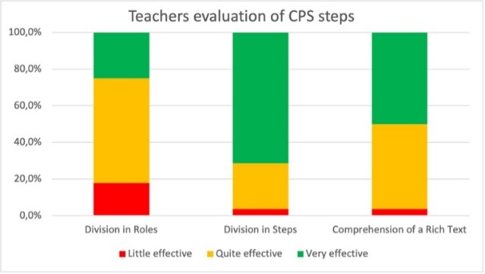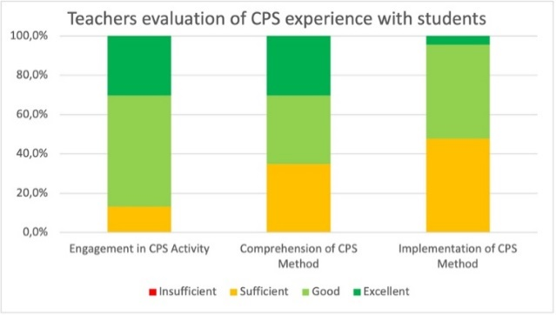
Figure 1. Left panel: Teachers evaluation of CPS steps. Right panel: Teachers evaluation of CPS experience with students.

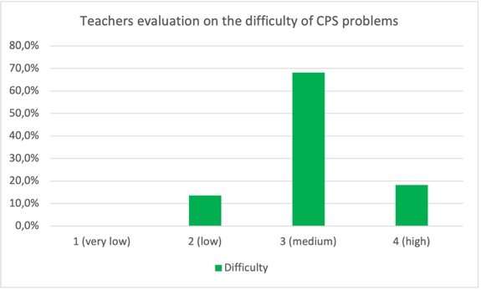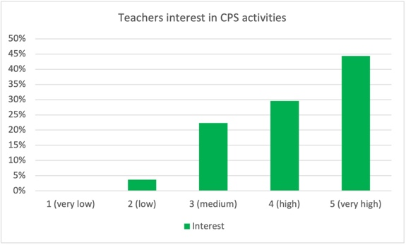
Figure 2. Left panel: teacher’s evaluation on the difficulty of CPS problems presented to students. Right panel: teacher’s evaluation on their interest in CPS activities.

Table 4. On the left, a schematic list of students’ questionnaire. On the right column, we indicate the number of answers we received from students (79), and show their results indicating the specific ranking scale for each section of the questionnaire.

Questions | Results (79 answers)
Section 1 | Ranking scale: 1 (no), 2 (partly), 3 (yes)
1. Comprehension of the problem  2. Comprehension of the step division  3. Comprehension of roles  4. Preparatory School activity on CPS | 1 2 3  0.0% 7.6% 92.4%  3.8% 26.6% 69.6%  0.0% 11.4% 88.6%  70.9% 0.0% 29.1%
Section 2 | Ranking scale: 1 (unsolved) – 3 (solved)
5. Evaluate step 1 (Focusing)  6. Evaluate step 2 (Description)  7. Evaluate step 3 (Planning)  8. Evaluate step 4 (Execution)  9. Evaluate step 5 (Evaluation) | 1 2 3  0.0% 3.8% 96.2%  1.3% 31.6% 67.1%  0.0% 13.9% 86.1%  2.5% 22.8% 74.7%  8.9% 31.6% 59.5%
Section 3 | Ranking scale: 1 (irrelevant) – 5 (essential)
Evaluate your contribution as a single to  10. find a solution of the problem  11. analyse the solution strategy  12. plan a mathematical solution  13. find/solve the proper equations | 1 2 3 4 5  2.5% 5.1% 29.1% 50.6% 12.7%  1.3% 3.8% 29.1% 39.2% 26.6%  1.3% 5.1% 30.3% 40.5% 22.8%  1.3% 5.1% 25.3% 46.8% 21.5%
Evaluate the group contribution to  14. find a solution of the problem  15. analyse the solution strategy  16. plan a mathematical solution  17. find/solve the proper equations | 1 2 3 4 5  1.3% 3.8% 29.1% 39.2% 26.6%  1.3% 1.3% 27.8% 43.0% 26.6%  2.5% 1.3% 27.8% 35.4% 33.0%  2.5% 3.8% 21.5% 36.8% 35.4%
Section 4 | Ranking scale: 1 (no), 2 (partly), 3 (yes)
18. Adequate level of knowledge  19. Enforceability of CPS method | 1 2 3  6.2% 29.6% 64.2%  11.1% 45.7% 43.2%
Section 5 | Ranking scale: 1 (very low) – 5 (very high)
20. Difficulty of the problem  21. Interest | 1 2 3 4 5  8.9% 27.8% 45.6% 17.7% 0.0%  2.5% 3.8% 20.3% 53.1% 20.3%

3.2 Analysis of Students Questionnaire
Among the 98 students participating at the CPS laboratory, only 79 (81%) of them decided to fill the questionnaire (see table 4 for a schematic list of questions and related answers). Regarding the CPS activity (figure 3) almost the totality (92%) declared to have completely understood the text and more than 80% partly or fully grasped the step-division. Roles were also easily complied with by more than 70% even though almost no preparation to CPS activity was provided at school. Students were required to self-evaluate their experience in solving a problem by means of CPS method (figure 3). Except for a critical 8% in solving the problem, the self-evaluation was largely positive, up to more than 96% for the focusing step. The contribution to the CPS activity as a single or as a group (figure 4) was also evaluated as quite effective, with minimal or irrelevant score being overall less than 10%. Finally, students evaluated if their level of physics knowledge was adequate or not to face up with the presented problem and, according to them, the enforceability (applicability) of the CPS method in a high school class (not reported for sake of brevity). The evaluation is again quite positive, with larger criticism for the applicability in class (only 42% of fully positive answers). This could be partly related to the perceived difficulty of the proposed problems (medium for about 45% of the students, figure 5), despite most of them expressed high interest in the method (75%).

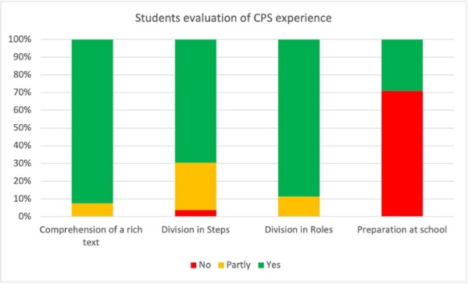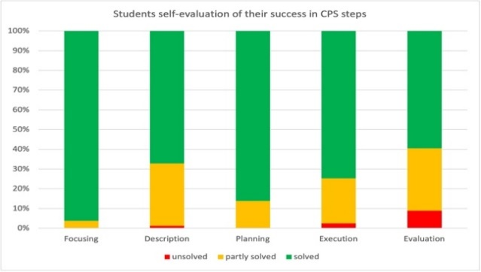
Figure 3. Students evaluation of CPS experience (left panel) and self-evaluation of their success in CPS steps (right panel).

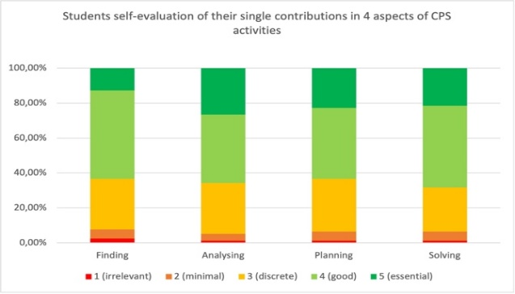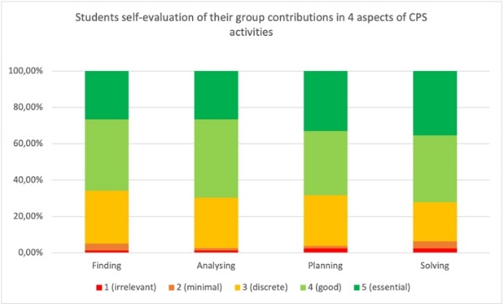
Figure 4.: Students self-evaluation of their contributions in 4 specific aspects of CPS activities, as single (left panel) or as a group (right panel).

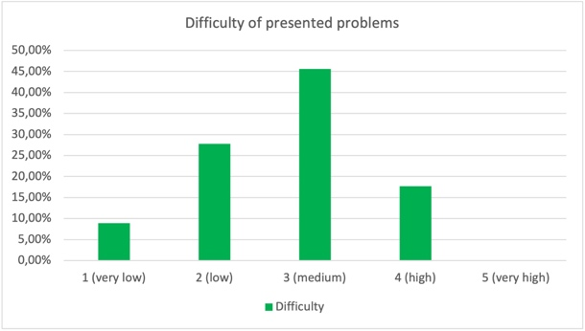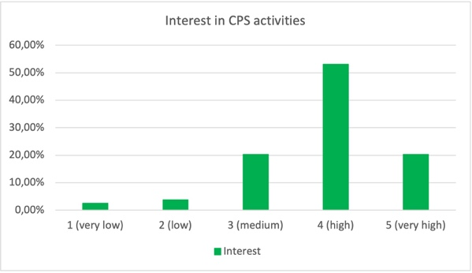
Figure 5. Students’ rates on the difficulty of the presented problems (on the left, a), and on their interest in the CPS activity (on the right, b).

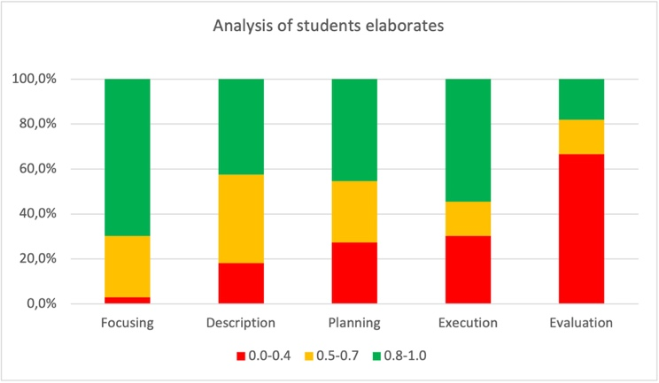
Figure 6. Analysis of the students elaborates.
3.3 Analysis of CPS elaborates
The analysis of the results on the elaborates are collected in figure 6, by grouping the scores as insufficient (0.0 – 0.4 range), sufficient (0.5 – 0.7 range) and good (0.8 – 1.0 range). As it is clear from the graph, the percentage of success decreases through the CPS steps, being however still restrained up to 30% but for the largely critical unsuccess in the evaluation step (67%).

4. Discussion
Teachers results on their experience in CPS laboratory are shown in figures 1 and 2. In general, the overall evaluation was positive, being the different aspects of CPS rated quite or very efficient by most of the teachers. Most of them also gave a positive evaluation on the replicability of the activity in high school classes, thus confirming the usefulness of the methodology with high school students.
It emerges that this experience allowed teachers to better understand the method and to evaluate its reliability in a class contest, suggesting an easier implementation in the last year classes of the high school where the age and expected ripeness of students could make easier management and supervision of student groups. It should be noted that, when privately interviewed about their roles as coachers during students CPS laboratory, teachers declared a minimal coaching activity, mainly devoted to simplifying understanding and separating the different steps of the method. Coaching was evaluated positively to ignite the discussion. The division in steps was found complex and somehow artificial, being not perfectly clear the separation among too many steps, somehow perceived as redundant. In general, the experience was evaluated as interesting (96% rated it >3 in a 1 – 5 scale).
The analysis of the questionnaire submitted to students attending CPS laboratory is reported in figures 3 – 5. In general, students feel confident with their comprehension of the problem and their capability to apply the solution method (“steps”), even though the matter was not prepared in class before attending the laboratory. Students also felt positive when appraising their contribution as a single or within the group cooperation (both rated at least discrete in general) and estimated as successful their results in each step of the method, being their physics knowledge evaluated as suitable for the proposed problem. The most appreciated aspect was the discussion within the group and the sharing of knowledge. Other beneficial aspects were the splitting in roles and the resolving scheme. Despite the difficulty of the proposed problem was rated between medium and low (about 75%), this aspect did not affect their interest in the CPS activity, rated as interesting by the majority of them (73%). A semi-qualitative comparison between teachers and student’s evaluation of these two items showing similar data distribution.
The analysis of the performance of students (figure 6) showed that they experienced increasing difficulties in the different steps of the solution scheme, with a large unsuccess in the evaluation step. The most part of the groups did not understand the request of evaluation and at most gave the easy answer as “yes” or “no”, despite they were advised that any results should be examined on a rational basis. It should be noted that this is in contrast with the student feeling of successfully reaching the solution. It indicates, in our opinion, that the general approach of the students to solve a problem is to find a number, with no further speculation on its reliability and soundness, evidencing a general lack of the capacity of abstraction and generalization. This was already reported in previous studies [4] and in general refers to the different approach of expert and novice to problem solving [12-14, 26]. Improving their critical sense is a crucial aspect to increase their problem-solving ability, allowing conversion of novices into experts and helping the students in developing a more objective self-analysis of their performances.

5. Conclusions
We proposed a course on the cooperative problem-solving technique (CPS) to high-school physics teacher and discussed with them its applicability to Italian high school classes. Beside the training course, we also simulated an application of the method to students from final years of high schools (10th to 12th grades) to verify how the students evaluate the new approach. During this laboratory activities, teachers acted as tutors or coaches. Teachers appreciated the method and suggested that classes in final years of high schools could be the proper ones where the method could be introduced because of the need of abstraction and speculation. The most appreciated aspects were the group working and the rich-context text of the problems, evaluated as really positive in stimulating student engagement, even though preparation of rich context problems requires lot of effort. The students appreciated the same aspects but perceived the problem division in different steps and somehow the role splitting as a compelling over structure. The analysis of their performance displayed a quite good success, considering that there was not, in general, previous preparation and it was their first attempt in CPS. However, the analysis also displayed some difficulties in separating the different steps of the methods, despite the use of a solution scheme, and, above all, showed a large fault in the self-evaluation process and in the evaluation of the reached results. These findings show that there is a large need to develop critical sense and abstraction abilities of students to improve their problem-solving skills, results which could be achieved by CPS implementation in high school classes.

Acknowledgements
We are grateful to all the faculty, teachers and students who allowed us to conduct the study and helped with the study. We are also grateful to the organizers of the PLS conference “Contribuire allo sviluppo professionale dei docenti di fisica nella scuola secondaria” for the occasion given to us to present the content of this paper during the event.

Disclosure statement
No potential competing interest was reported by the authors.

References
[1] Balta, N., & Asikainen, M. A. (2019). Introductory students’ attitudes and approaches to physics problem solving: Major, achievement level and gender differences. Journal of Technology and Science Education. https://doi.org/10.3926/JOTSE.666

[2] Ganina, S., & Voolaid, H. (2011). Impact of problem solving on the effectiveness of studying physics. an example of dispersed data problems. Journal of Science Education and Technology, 12(2), 72–75.

[3] Hoskinson, A. M., Caballero, M. D., & Knight, J. K. (2013). How canwe improve problem solving in undergraduate biology? applying lessons from 30 years of physics education research. CBE Life Sciences Education. https://doi.org/10.1187/cbe.12-09-0149

[4] Ince, E. (2018). An Overview of Problem Solving Studies in Physics Education. Journal of Education and Learning. https://doi.org/10.5539/jel.v7n4p191

[5] Sezgin Selçuk, G., & Çalýskan, S. (2008). The effects of problem solving instruction on physics achievement, problem solving performance and strategy use. Latin-American Journal of Physics Education.

[6] Shishigu, A., Hailu, A., & Anibo, Z. (2018). Problem-based learning and conceptual understanding of college female students in physics. Eurasia Journal of Mathematics, Science and Technology Education. https://doi.org/10.12973/ejmste/78035

[7] Wiyanto. (2019). Learning transferable skills: The role of physics education in the era of disruptive innovation. Journal of Physics: Conference Series. https://doi.org/10.1088/1742-6596/1170/1/012007

[8] Dhillon, A. S. (1998). Individual differences within problem-solving strategies used in physics. Science Education. https://doi.org/10.1002/(SICI)1098-237X(199806)82:3<379::AID-SCE5>3.0.CO;2-9

[9] Johnson, S. D. (1994). Research on problem solving instruction: What works, What doesn’t? The Technology Teacher, 53(8), 27–29.

[10] Bergin, S. D., Murphy, C., & Shuilleabhain, A. N. (2018). Exploring problem-based cooperative learning in undergraduate physics labs: Student perspectives. European Journal of Physics. https://doi.org/10.1088/1361-6404/aa9585

[11] Docktor, J. L., Strand, N. E., Mestre, J. P., & Ross, B. H. (2015). Conceptual problem solving in high school physics. Physical Review Special Topics - Physics Education Research. https://doi.org/10.1103/PhysRevSTPER.11.020106

[12] Heller, P., Keith, R., & Anderson, S. (1992). Teaching problem solving through cooperative grouping. Part 1: Group versus individual problem solving. American Journal of Physics. https://doi.org/10.1119/1.17117

[13] Heller, P., & Hollabaugh, M. (1992). Teaching problem solving through cooperative grouping. Part 2: Designing problems and structuring groups. American Journal of Physics. https://doi.org/10.1119/1.17118

[14] Huffman, D. (1997). Effect of Explicit Problem Solving Instruction on High School Students’ Problem-Solving Performance and Conceptual Understanding of Physics. Journal of Research in Science Teaching. https://doi.org/10.1002/(SICI)1098-2736(199708)34:6<551::AID-TEA2>3.0.CO;2-M

[15] Leonard, W. J., Dufresne, R. J., & Mestre, J. P. (1996). Using qualitative problem‐solving strategies to highlight the role of conceptual knowledge in solving problems. American Journal of Physics. https://doi.org/10.1119/1.18409

[16] Çalişkan, S., Selçuk, G. S., & Erol, M. (2010). Effects of the problem solving strategies instruction on the students’ physics problem solving performances and strategy usage. Procedia - Social and Behavioral Sciences. https://doi.org/10.1016/j.sbspro.2010.03.315

[17] Gok, T. (2010). The General Assessment of Problem Solving Processes and Metacognition in Physics Education. Eurasian Journla of Physics and Chemistry Education.

[18] Gök, T., & Sýlay, I. (2010). The Effects of Problem Solving Strategies on Students’ Achievement, Attitude and Motivation. Latin-American Journal of Physics Education.

[19] Bell, E. T., & Polya, G. (1945). How to Solve It. A New Aspect of Mathematical Method. The American Mathematical Monthly. https://doi.org/10.2307/2306109

[20] Bransford, J. D., & Stein, B. S. (1993). The IDEAL problem solver (2nd ed.). New York: Freeman.

[21] Hidayati, H., & Ramli, R. (2018). The Implementation of Physics Problem Solving Strategy Combined with Concept Map in General Physics Course. IOP Conference Series: Materials Science and Engineering. https://doi.org/10.1088/1757-899X/335/1/012077

[22] Jua, S. K., Sarwanto, & Sukarmin. (2018). The profile of students’ problem-solving skill in physics across interest program in the secondary school. Journal of Physics: Conference Series. https://doi.org/10.1088/1742-6596/1022/1/012027

[23] Yerushalmi, E., Cohen, E., Heller, K., Heller, P., & Henderson, C. (2010). Instructors’ reasons for choosing problem features in a calculus-based introductory physics course. Physical Review Special Topics - Physics Education Research. https://doi.org/10.1103/PhysRevSTPER.6.020108

[24] Piaget, J. (2013). Origin of Intelligence in the Child. In Origin of Intelligence in the Child.
https://doi.org/10.4324/9781315006260

[25] Mazur, E. (2008). Peer instruction: Getting students to think in class.
https://doi.org/10.1063/1.53199

[26] Chi, M. T. H., Feltovich, P. J., & Glaser, R. (1981). Categorization and representation of physics problems by experts and novices. Cognitive Science https://doi.org/10.1207/s15516709cog0502_2

[27] Piano Lauree Scientifiche (PLS). https://www.pianolaureescientifiche.it/

Supplementary Files
SF1: List of text-enriched problems presented to students
Problem A: Throwing away all caution you could not resist the temptation of a piece of an ice cream cake at the party of your friend. Feeling remorseful, you look at the back of the package and discover that a portion of cake has a content of 400 Calories. Since you don’t want to frustrate the diet of the last three months, you decide to go to the gym to do some weightlifting to burn these calories. Before leaving the house, however, you think about it and calculate how many times you should lift a weight of 10 kg to a height of 1 m. So, you wonder if it’s wiser for the future to resist temptation.

Problem B: While you are at the restaurant, a friend of yours tells you about research on the so-called dark matter. According to Newton’s theory of gravitation, planets orbit around a star or stars around the galactic center with decreasing velocities as a function of their distances from the centre. Numerous observations have shown that the velocity of these objects stops decreasing in the outermost parts and a possible interpretation of this phenomenon is the presence of additional "dark" matter not visible (because it does not emit light), in addition to that assumed in the most central areas of galaxies. Fascinated by the idea, since you have just studied the planetary motions, you decide to calculate the speed and kinetic energy of a planet in orbit around a star as a function of the radius of the orbit and the masses of the planet and the star. Then you compare the rotational velocities and kinetic energies of Earth and Jupiter, whose orbital radii are 150 x 10⁶ km and 778 x 10⁶ km, respectively. The mass of the Sun is about 2 x 10²⁰ kg, the mass of the Earth is 2 x 10²⁴ kg. Jupiter is 318 times massive than the Earth.

Problem C: While you’re at the restaurant, your friend tells you about a book about the structure of atoms. He read that according to Bohr’s theory, electrons are in a uniform circular motion around the nucleus. Imagining that the atom is a microscopic planetary system, you decide to calculate the kinetic energy of an electron orbiting a proton in a hydrogen atom as a function of the radius of the orbit and the properties of the electron and proton. Calculate what the kinetic energy is worth for the radius of the smallest orbit, which is 0.5 x 10⁻¹⁰ meters.

