Le vignette scientifiche come strumento per stimolare l’apprendimento della fisica moderna nella scuola primaria
Using concept cartoons as a tool to foster modern physics in primary schools
Matteo TUVERI¹, Marta FANTONI², Alessia ZURRU^{1,3}, Viviana FANTI^{1,3}, Carlo Maria CARBONARO³
¹Istituto Nazionale di Fisica Nucleare, Sezione di Cagliari, Cittadella Universitaria di Monserrato, sp 0,700, 09042, Monserrato (Italia)
²IMT School for Advanced Studies, Piazza San Francesco 19, 55100, Lucca (Italia)
³Dipartimento di Fisica, Università degli Studi di Cagliari, Cittadella Universitaria di Monserrato, sp 0,700, 09042, Monserrato (Italia)
Abstract La fisica è spesso considerata dagli studenti come una materia complessa e difficile da apprendere. Tra le ragioni che portano a tali considerazioni vi è il fatto che l’indagine fisica sia rivolta a fenomeni spesso non osservabili con i nostri sensi, ma i cui effetti macroscopici sono spesso tangibili. È compito degli insegnanti trovare ed applicare nuove metodologie di insegnamento della fisica, affinché gli alunni possano avere un’esperienza più coinvolgente ed interessante durante le fasi di apprendimento della materia. L’arte e il cosiddetto “visual thinking” rappresentano strumenti utili per stimolare l’interesse della classe sui temi scientifici. Il ruolo delle strategie educative basate sull’arte e i loro effetti benefici sugli alunni sono stati ampiamente documentati in letteratura. Queste tecniche supportano gli studenti nello sviluppo di abilità di pensiero critico, rafforzano le loro abilità comunicative ed osservative, stimolano l’apprendimento di gruppo e la cooperazione. L’utilizzo del disegno e, in particolare, delle vignette “scientifiche”, favoriscono l’apprendimento dei contenuti veicolati durante le lezioni, aiutando gli alunni nello sviluppo di una maggiore self-confidence nel processo di studio. Inoltre, favoriscono lo sviluppo dell’immaginazione e dell’intuizione scientifica, aiutando a colmare il vuoto lasciato dall’osservazione sensoriale. Gli stessi fisici come Einstein, Feynman e Heisenberg imputavano all’apprendimento visuale della fisica un ruolo fondamentale anche nelle loro ricerche, dichiarando come la comprensione di un fenomeno da essi studiato fosse sempre mediata da un’intuizione visuale del fenomeno. In questo lavoro, proponiamo una strategia educativa basata sull’uso delle vignette scientifiche per favorire l’apprendimento delle teorie della relatività speciale e generale di Einstein nella scuola primaria. In particolare, mostreremo tre vignette disegnate da noi per questo scopo e discuteremo il ruolo del docente all’interno delle attività di classe come guida e facilitatore della comprensione di alcuni fenomeni narrati tramite le vignette stesse.
Abstract Learning physics is often considered a difficult task by students. Physics investigation aimed to analyse phenomena often not observable with our senses, but whose macroscopic effects are often tangible. It is a teacher' task to find and apply new teaching methodologies to engage and interest students in physics’ learning experience. Art and the so-called "visual thinking" are valuable tools to stimulate the class’ interest on these topics. The role of art-based educational strategies and their beneficial effects on pupils have been widely documented in the literature. They support students in developing critical thinking skills, strengthen their communication and observation skills, stimulate group learning and cooperation. In particular, the use of drawing and, scientific concept cartoons foster in-class learning and helps pupils to develop their self-confidence. It also helps develop their imagination and scientific intuition, filling the conceptual void left by the lack of a sensory observation of physical phenomena. Einstein, Feynman and Heisenberg attributed a fundamental role to visual learning in physics and in their research, declaring that a visual intuition mediated the understanding of a phenomenon. In this paper, we propose an educational strategy based on the use of scientific concept cartoons to facilitate Einstein's theories of special and general relativity in primary school. In particular, we will present three cartoons that we designed for this purpose, and we will discuss the role of the teacher within the classroom activities as a guide and facilitator of the understanding of phenomena showed in the cartoons.
1. Introduction
Physics is around us. The sunlight, the wind, or sound, but even our mobile phones, laptops, and televisions rely on physical principles. Modern technology is the result of discoveries that have completely changed our understanding of the universe, namely Einstein’s general and special relativity theories and quantum mechanics. The former studies macroscopic physics, the motion of planets around stars, the formation of galaxies and the origin of our universe, and also the motion of satellites orbiting the Earth. Thanks to satellites, and thus, thanks to general relativity, we use the Global Positioning System (GPS) to reach a traveling destination with high precision. Quantum mechanics studies the microscopic world, but its application in our everyday lives spans from our mobile phones' microelectronics to the invention of the World Wide Web (WWW) and nuclear medicine.

The subjects investigated by these two physics branches seem to be very far away from our experience and are even further away from school programs. It can be due to the conceptual difficulties in understanding the physics behind the explanation of phenomena regarding the micro and macro worlds. From primary to secondary schools, quantum mechanics and special and general relativity topics are missing. Nevertheless, even if (contemporary) physics is usually addressed to unobservable and unconcreted phenomena, teachers should consider a new way to introduce such topics in their lectures, especially for their importance in our everyday lives and human progress. They have also to make the process of learning physics more enjoyable, employing alternative and more involving teaching strategies, which in turns, can overcome the conceptual difficulties characterizing contemporary physics.

Cooper and McIntyre [1] argue that students enjoyed teaching strategies that motivate them to learn. Several studies have shown that visual contents motivate and involve students in education, capturing their attention and fostering their critical thinking abilities [2]. Ainsworth and colleagues [3] noticed that scientists do not use only words to explain scientific contents; they also rely on diagrams, graphs, videos, and photographs to support their findings in the explanations, which is a process that seems to be appreciated by the public interest. The need to overcome natural language deficit in explaining concepts is at the basis of scientific intuition. It is a process that philosophers call conceptual thinking [4]. There are many examples in physics of such a process, and perhaps the most famous instance of this feeling is provided by Albert Einstein. In his autobiographical notes, he quoted his letter to Jacques Hadamard [5], who was investigating the creative process querying many mathematicians and scientists about their mental processes [6-8]. Einstein asserted:

“The words or the language, as they are written or spoken, do not seem to play any role in my mechanism of thought. The psychical entities which seem to serve as elements in thought are certain signs and more or less clear images which can be "voluntarily" reproduced and combined ...”.

Richard Feynman says something similar [3]:

“What I am really trying to do is bring birth to clarity, which is a half-assedly thought-out pictorial semi-visual thing ... It’s all visual. It’s hard to explain” (Interview in Glieck, 1993).

Visual and conceptual thinking are widely used in contemporary physics, where phenomena have little contact with the world of our senses’ experiences [3]. Feynman’s diagram to explain the interactions of subatomic particles is another visual representation of what is not tangible or visible to our senses, nor is it easily comprehensible for non-physicists. In explaining quantum mechanical phenomena, Heisenberg asserted that it is next to impossible to talk about quantum physics in a non-scientific language.

In education, processing information through images instead of words only [9-13] finds a natural application in constructivist learning environments, where students are motivated to employ resources and tools in a setting with abundant resources [14]. Students' construction of new knowledge while anchoring learning in real-world contexts makes the students' knowledge meaningful. Visual representations help students elaborate their knowledge, understand it better, and better remember it. When students support and give meaning to their elaborations, learning is more robust (see [15] and references therein). Visual representation has been shown to encourage further constructive strategies, such as drawing or inventing visual representations, which can be considered the basis for future learning processes [3].

Einstein's, Heisenberg's, and Feynman's approaches to physics investigations are clear examples of what is called visual thinking. Unlike other constructive strategies, such as writing summaries or providing oral self-explanations, visual thinking is a form of visual representation with distinct attributes that match the visual-spatial demands of science learning [3]. Visual thinking is the ability to deal with and manipulate visual information, and it is one of the mind's most potent capacities [7]. Visual thinking strategies in education have been invented by Abigail Housen, a cognitive psychologist, and Philip Yenawine, an art educator. They developed tools to promote aesthetic development and assist empathic understanding of others' visual world experience through visual art. These strategies use art to encourage students to develop critical thinking, communication, observation skills, and group participation thought processes [16]. The importance of implementing such visual thinking strategies in science is underlined by West [17], who believes that we may be going into a new era where visual thinking will be an essential tool to find new creative solutions to problems.

Scientific concepts depend on human perception and, since any view requires visual perception and decoding of visualization, it is possible to consider visual thinking as an essential tool in science education [18]. In pupils' case, it has been demonstrated that the more images there are, the better they understand and realize information. The role of symbols is vital in memorization and coding information, primarily if used while listening [19]. Visual perception is a mechanism that allows one to perceive and elaborate visual stimuli. It also connects the awareness in creating an image, the conduction and link of different ideas, the process of recalling and planning. In teaching science, visual imagery can help to imagine the phenomenon of nature when they are recalled by the perception in memory [18,20,21]. In science education, it provides a valuable tool to help the students in the decoding of information and in learning complex concepts. Since vision is primarily based on the perception and decoding of visual stimuli, we can state that visual thinking assumes an essential role in science education. Many disciplines have as objects of study "things" that are not visible with the naked eye, but several concepts need to be visualized by pupils to be completely comprehended. Visual thinking is relevant for students of every age because using visual perception, learners can select the information and elaborate them to a higher level. In this way, the view registers in the conscious, and the complex concepts are easily comprehensible, helping in learning and understanding science. Visualization helps forming the suitable visual mental model because it is decoded and presented in the mind or visible manifestation. Visual thinking contributes to perceive, decode and imagine visual information, build mental models with the help of memory, and comprehend information is processed to stay in long-term memory [18].

Among the visual thinking strategies, concept cartoons have been developed to create innovative teaching and learning strategies that consider a constructivist approach to learning in science [22] and physics in particular [23]. Studies have shown that more than 70% of the respondents have positive views on the impact of cartoons on teaching and learning. Teachers who applied these methods realized that teaching and learning using cartoons could create a positive learning environment for the students, stimulating their imagination and creativity [23].

This paper proposes an educational training activity based on visual strategies to bring Einstein’s relativity to primary schools. We review the role of concept cartoons in education and how they can be applied as an educational tool in school. We show three concept cartoons designed by us for a suitable target (primary school students). The cartoons deal with some peculiar aspects of Einstein’s special and general relativity. We finally discuss how to integrate them as a material to make pupils aware of modern physics phenomena and foster physics in primary schools.
2. Learning physics by art: concept cartoons
Creativity is one of the critical features of physics. Building experiments or creating new theoretical models that can help understand the mechanism of nature needs a high level of creativity, which is often accompanied by imagination. Imaginative thinking strategies are helpful in the informal learning of science [8,24]. Imagination is an instrument that involves meaningful and authentic activities that help students in constructing their understanding of problems and the skills needed to solve them [14]. Replacing memorization with exploration and invention is, therefore, important in science education [15,25].

One way to catalyze creativity and imagination in science is to use concept cartoons. Cartoons are visual tools that combine drawn characters with dialogues related to everyday events in a humorous and satirical fashion [26-30]. They are often used as material to enhance the public understanding of science [31,32]. Positive effects of cartoons have been found when applied in teaching: they create and maintain students' interest and encourage them to think. Cartoons foster active participation in learning, encouraging pupils to discuss their content and their conceptual meaning. Drawing or creating their cartoons is highly recommended [32]. Indeed, the students' cartoons encouraged them to think about specific issues and expressed a stance on the issue. The positive outcomes of such a visual thinking strategy are evidenced in the literature regarding the use of cartoons in physics, chemistry, and mathematics education [27,33-36].

Concept cartoons can be used in the classroom within a classical teaching sequence to generate discussion, encourage investigation, and challenge learners' understanding within regular teaching sessions. Also, they can be applied for assessment. A lesson based on the cartoons' concept can follow the following lines [31]: a brief introduction to the activity and then cartoons consultation. After that, learners are invited to reflect on the main concepts that the cartoons transmitted and discuss what they think about it and their point of view. In this part, the teachers act as facilitators, promoting the interaction and the intervention of students, engaging them in sharing and discussing their ideas. Among the others, a much broader range of applications of concept cartoons in the classroom includes material for homework, in-class discussion about cartoon's content, and dialogues in the speech bubbles. The latter is often used to measure assessment. Concept cartoons are also used as research instruments to explore learners' scientific thinking or illustrate the nature of science, including alternative viewpoints.

Cartoons and comics are featured with a form of communication that is important for both communication and education: storytelling. Storytelling is a narrative technique that has been considered a tool in education for its fundamental capacity to foster memory acquisition, simulate the social experience, and a powerful mechanism to transport into fictional worlds, relying on emotions. Narratives and storytelling are intrinsically easier to remember due to their cause-effect structure, and the message they carry can have long-lasting effects on the reader's beliefs and behaviors [31]. Storytelling is one of the narrative components of concept cartoons, where the topic is presented in an argumentative manner, and dialogues between characters and their opinions are taken from everyday life [31]. The learners are then asked to argue with the characters [34]. Concept cartoons help the students to question their thoughts and foster their problem-solving skills [38].
Table 1. A model for a training activity using visual thinking strategies and concept cartoons

Training Activity | Time duration
Visual thinking and related strategies in education | 2 hours
Physics (history, phenomenology, experiments) | 2 hours
Concept cartoons  - In-class discussion and debate about physics behind the cartoon  - Experience and common-sense vs represented physical situation  - Laboratory about physical content of the cartoon | 1 hour (each)
Hands-on and minds-on activity  - Drawing a concept cartoon and discuss its content with students | 1h 30 m
Final test: realization of a laboratory with a class based on tasks above | 2 h 30 m
Final brainstorming | 1 hour
3. Einstein’s relativity at primary schools: an educational training activity for teachers
Learning physics in a student-centered constructivist environment, in which the student is involved in a learning-by-doing process based on life experiences, is becoming more and more important in education. Any training activity addressed to any teacher should consider this paradigm, especially in the case of primary school teachers, where pupils are experiencing physics for the first time. Learning by doing with the aim of arts and visual thinking strategies exactly goes in this direction.
A training activity for primary school teachers based on visual thinking strategies and concept cartoons to introduce pupils to contemporary physics contents is shown in table 1. Its general design makes the proposed laboratory suitable to train teachers to physics and consequently to introduce them to visual thinking strategies and any scientific argument. In what follows, we show and discuss the physical content of three concept cartoons designed by us to bring Einstein’s relativity to primary school. We also propose pedagogical elements to use them as a teaching tool for teachers.
3.1 Einstein’s relativity and concept cartoons
Concept cartoons regarding Einstein’s theories of relativity are shown in figures 1, 2, and 3. Two characters appear in the story: two animals with human forms, a fox, and a pink flamingo. They have interchangeable roles in telling the story. Scenes are set in our everyday life experiences. The fox plays a scientist's role resembling Albert Einstein, whereas the pink flamingo is the scientist's partner-in-crime. The scientist sometimes plays the skeptic role, sometimes is the investigator (and vice versa for the pink
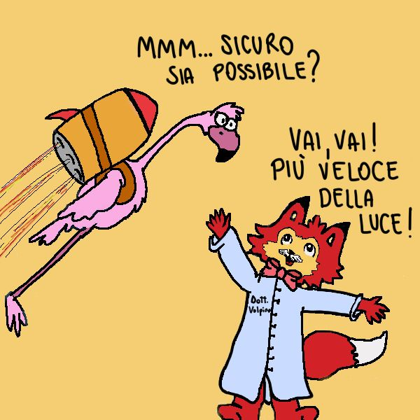
Fig. 1 The story deals with special relativity and with the limit on the speed of light. English translation: the fox says: “Go, Go! Faster than light!”. The pink flamingo answers: “Mmm (dubious) … are you sure that is it possible?”.
flamingo). The skeptic’s task is to prove (or disprove) the goodness of the scientific ideas proposed by the other character. The panels show some experiments realized with objects taken from our everyday life, such as a mobile phone, a ladder, or a rocket. Narratives are made by simple sentences composed of few words, sometimes as questions or observations. Sentences create a dialogue between characters dealing with the scientific content of the story.
The cartoons deal with special relativity (the fundamental postulate about the speed of light, see figure 1), Einstein's elevator thought experiment about the nature of gravity (see figure 2), and cosmology (more precisely, issues related to the accelerated expansion of the universe, see figure 3).
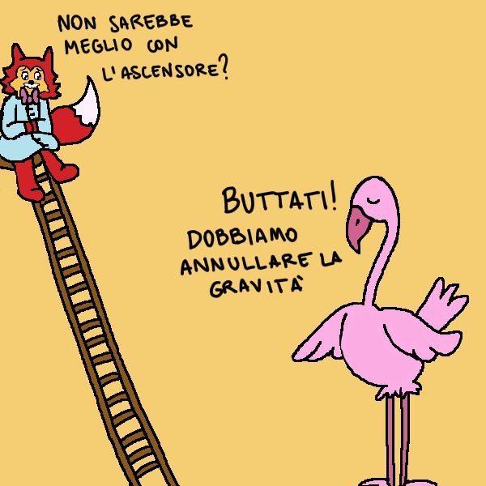
Fig. 2 The story deals with General Relativity and the famous thought experiment on the elevator. The pink flamingo says: “Jump, we have to eliminate the effects of gravity”. The fox answers: “Wouldn’t be better to try with an elevator?”
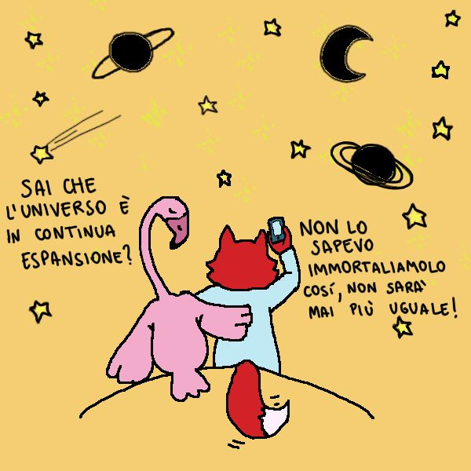
Fig. 3 The cartoon introduces the reader to the concept of an expanding universe. The pink flamingo says: “Did you know that the universe is expanding? Didn’t you?” and the fox answers: “I did not! Let’s do a picture now, it will be not the same anymore!”
4. Discussion
The cartoon in figure 1 deals with one of the fundamental postulates of special and general relativity: nothing can move faster than light [39]. The humoristic vein of the dialogues invites the reader to think about the physical consequences contained in the story. Since the fox has some similarities with Einstein, one expects it tells the truth about the possibility of going faster than light. The flamingo raises a question to reason about the truthfulness of foxes' speech. This role reversal mixed with humor and comics in presenting the experiment shows the importance of making errors in science to reach the research goal. The skeptic points out the need to perform experiments and verify hypotheses about possible explanations of physical phenomena.
In figure 2, storytelling is about the famous Einstein's thought experiment of the elevator [39]. In his famous experiment, Einstein imagined having a lab in a closed space, such as an elevator. An observer inside the lab holds a ball in his hands and throws it from one hand to the other. If the lab is stationary on the surface of the Earth, thanks to the Earth’s gravitational field, we will observe the ball following a downward parabolic trajectory. If the laboratory is in empty space and is stationary or moving inertially with constant speed and direction in an upward direction with respect to the earth, the ball will appear to travel straight across the lab. Imagine now a situation where the lab is in empty space but is accelerated upward with a constant acceleration, as when an elevator ascends. One will see the same thing that one saw in the lab at rest in the Earth’s gravitational field. Einstein realized that no experiment performed inside the closed lab could distinguish between the lab’s being in a strong gravitational field and it is being accelerated rapidly upward. In our cartoon, the pink flamingo involves the experimenter in a joke about the possibility of eliminating gravity by jumping from the top of a ladder to the ground. The scared fox suggests using the elevator to reproduce the famous Einstein's thought experiment, through which the physicist guessed the nature of gravity and its connection with the acceleration of a moving body in a gravitational field. However, to fully reproduce the elevator thought experiment, characters in the cartoon should be in empty space, far away from objects that can attract them due to their gravitational field. Since the scene is supposed to be set on the Earth's surface, the fox is attracted by the Earth, making it impossible to reproduce Einstein's results. If used in education, the teacher can guide pupils' discussion about the drawn experimental setup's reliability compared to the actual Einstein's thought experiment. The class activity has to be also driven towards a discussion about the meaning of gravity and acceleration. This cartoon offers the possibility to introduce general relativity in the classroom by mentioning the role of imagination in the scientific process, the role of thought experiments to visualize phenomena that are not explicit to our sight and foster visual concepts in learning physics.
The cartoon in figure 3 deals with cosmology and the accelerated expansion of the universe [39]. Einstein's general relativity equations predict the latter, and it has been observed experimentally [40]. The cartoon represents two characters sat in front of the sky chatting about the nature of the universe. The scene is set in an everyday life situation, using mobile phones to take a photo of what the twos are seeing. The storytelling is fictionalized in order for the reader to feel comfortable with what is told in the story. As previously mentioned, this element helps memorize the cartoon's content and fosters learning. The cartoon can be used to introduce cosmology concepts in the classroom. Guided by the teacher, pupils can discuss the significance of what they are seeing, even on the reliability of the dimension of the objects appearing in the sky. One peculiar feature shared by all the cartoons is the story setting: scenes are set in familiar context with the presence of everyday life instruments such as the ladder or the smartphone. The choice of the framework is not casual, but it goes in the direction of what previously said about the features that concept cartoons should have to obtain positive outcomes in readers and students. We also draw the attention of the reader to the choice of the characters: narrative relies on the dialogue between two characters. This is to give to the reader the idea that physics, and more in general science, is made by a collaboration of individuals. Even if this is quite obvious for experimental disciplines, this is also true in the case of theoretical physics. Einstein himself could arrive at the formulation of his theories thanks to the collaboration with other scientist who gave their contribution in the developing of the work.
5. Conclusions
Significant efforts have been profound in contextualizing storytelling about general and special relativity into everyday life experiences. To bring people close to the counterintuitive and untouchable phenomena described by Einstein’s relativity, we tried to bring the latter into a reliable word, made of simple examples and familiar situations derived from our experience. We used concept cartoons to foster the understanding and learning of physics in primary schools (as well as in social media). Children have to participate in scientific practices seeing science in their home and school activities, measuring, building and designing, experimenting, and observing [41]. To make informal and formal science content relevant and meaningful for non-experts and pupils, attractive, visual, and interacting contents should be presented (see also [42-49] in an innovative way to teach gravity in schools).
Learning is not just a matter of scientific literacy. It is necessary to understand and use scientific knowledge to participate as an informed citizen in the decision-making and sustainable development of science and technology [23]. Cartoons have a positive impact in terms of learning, motivation, and interests. Thus, they can attract more students to learn science and, in particular, physics. Indeed, as we have already specified, due to the problematic aspects that characterize physics' learning, it is essential to find new skills to teach this discipline efficiently. Visual thinking strategies give students a valuable tool to improve their learning and understanding of physics. If appropriately designed, according to our general model shown in table 1, training activities based on visual thinking strategies can give teachers further instruments to bring contemporary physics elements into their classroom, guiding pupils in discovering peculiar features of Einstein's relativity theories and promoting the development of their visual literacy and thinking skills. Suitably trained teachers could use concept cartoons in education as material for learning or as a tool for asynchronous classroom activities, especially in primary schools. They can represent a useful instrument to trigger discussion among pupils and foster the learning of nature's laws, helping in spreading the scientific method and reasoning among the learners.

Acknowledgements
We are grateful to the organizers of the PLS conference “Quale didattica della fisica per formare gli insegnanti di scuola?” for the occasion given to us to present the content of this paper during the event.

References
[1] Cooper P and Mcintyre D 1996 Effective teaching and learning: teachers’ and students’ perspectives Buckingham: Open University Press.
[2] Frey N and Fisher D 2008 Teaching visual literacy: using comic books, graphic novels, anime, cartoons, and more to develop comprehension and thinking skills Thousand Oaks, California Corwin Press pp 195 ISBN 978-1-4129-5311-5, 978-1-4129-5312-2
[3] Ainsworth S, Vaughan P and Russell T 2011 Drawing to learn in science, Science vol 333, issue 6046, pp 1096-1097 DOI: 10.1126/science.1204153
[4] Smith C U M 2008 Visual thinking and neuroscience Journal of the History of the Neurosciences, 17:3, pp 260-273, DOI: 10.1080/09647040701436475
[5] Hadamard J 1954 The psychology of invention in the mathematical gield, Dover, New York
[6] Einstein A 1970 Autobiographical notes In: Schlipp PA, ed., Albert Einstein: Philosopher Scientist, The Library of Living Philosophers 3rd Edition. London, Cambridge University Press.
[7] Benzon W L 1990 Visual thinking, published in Allen Kent and James G. Williams, Eds. Encyclopedia of Computer Science and Technology vol 23, supplement 8. New York; Basel: Marcel Dekker, Inc. pp 411-427
[8] Hadzigeorgiou Y and Fotinos N 2007 Imaginative thinking and the learning of science The Science Education Review, 6(1)
[9] Bruner J 1966 Toward a theory of instruction Cambridge, MA.: The Harvard University Press.
[10] Schacter J, Heri H, Chung G, O’Neil H, Dennis R and Lee J 1997 Feasibility of a web-based assessment of problem solving Annual Meeting of the American Educational Research Association Chicago, IL, USA
[11] Rieber L 1994 Computers, graphics, and learning Madison: Brown & Benchmark Publishers.
[12] Rieber L 1994 Visualization as an aid to problem-solving: Examples from history In Proceedings of selected research and development presentations at the 1994 National Convention of the Association for Educational Communications and Technology Nashville TN. USA.
[13] Olson J 1992 Envisioning writing. NH.: Heinemann.
[14] Wilson B 1996 Constructivist learning environments Englewood Cliffs N.J.: Educational Technology Publications.
[15] Plough J 2004 Students using visual thinking to learn science in a web-based environment
[16] Klugman C M, Peel J and Beckmann-Mendez D 2011 Art rounds: teaching interprofessional students visual thinking strategies at one school Academic Medicine vol. 86, No. 10
[17] West T G 1997 In the mind’s eye Amherst, N.Y.: Prometheus Books
[18] Bilbokaitė R 2008 Analysis of visual thinking meaning in science education Problems of education in the 21st century Vol 4
[19] Snambaugh R N 1994 Personalized Meanings: The cognitive potentials of visual notetaking The Anual Eastern Educational Reasearch association conference, Sarasota
[20] Marks D F 1999 Consciousness, mental imagery and action British Journal of Psychology. Vol. 90, pp 567-585.
[21] Kosslyn S M, Ganis G, Thompson W L 2001 Neural foundations of imagery Neuroscience, Vol. 2, pp 635-641-642.
[22] Keogh B and Naylor S 1999 Concept cartoons, teaching and learning in science: an evaluation, International Journal of Science Education Vol 21 No. 4, pp 431-446, DOI:10.1080/095006999290642
[23] Khalida H, Subahan Meeraha T and Halima L 2010 Teachers’ perception towards usage of cartoon in teaching and learning physics, International Conference on Learner Diversity, Procedia Social and Behavioral Sciences 7 (C) pp 538–545
[24] Perales‐Palacios F J and Vílchez‐González J M 2005 The teaching of physics and cartoons: can they be interrelated in secondary education? International Journal of Science Education, vol 27 issue 14, pp 1647-1670, DOI: 10.1080/09500690500206366
[25] White A 1999 Six steps toward science and math literacy Scientific American http://www.sciam.com/article.cfm?articleID=000922CB-EB4A8809EC588EEDF
[26] Ingec S K 2008 Use of concept cartoons as an assessment tool in physics education US-China Education Review Vol 5, No.11 (Serial No.48), ISSN1548-6613, USA
[27] Keogh B and Naylor S 2000 Teacher and learning in science using concept cartoons: Why Dennis wants to stay in at playtime Australian Primary and Junior Science Journal Vol 16 No.3
[28] Naylor S, Downing B and Keogh B 2001 An empirical study of argumentation in primary science, using concept cartoons as the stimulus. Paper presented at 3rd European Science Education Research Association Conference, Thessaloniki, Greece
[29] Stephenson P and Warwick P 2002 Using concept cartoons to support progression in students’ understanding of light Physics Education, 37(2), pp 135-141
[30] Coll R K 2005 The role of models/and analogies in science education: implications from research International Journal of Science Education 27(2) pp 183-198
[31] Mcvicker C 2018 Visual literacy and learning to read: using comic strips for reading instruction, Journal of Visual Languages & Computing
[32] Eulie J 1969 Creating interest and developing in the social studies through cartoon Peabody Journal of Education 46(5) pp 288-290
[33] İngeç Ş K, Yıldız İ and Ünlü P 2006 Identification of misconception about uniform circular motion by the use of concept cartoons, VII National Science and Mathematics Education Conference, September 6-8, Ankara, Turkey
[34] Kabapınar F 2005 Effectiveness of teaching via concept cartoons from the point of view of constructivist approach Educational Sciences: Theory & Practice (KUYEB), 5(1), pp 135-146
[35] Uğurel I and Morali S 2006 Cartoons and their use in mathematics teaching Journal of National Education, p 170
[36] Chambers S and Andre T 1997 Gender, prior knowledge, interest and experience in electricity and conceptual change text manipulations in learning about direct current Journal of Research in Science Teaching, 34, pp 107-123.
[37] Farinella M 2018 The potential of comics in science communication JCOM 17 (01), Y01. https://doi.org/10.22323/2.17010401
[38] Dabell J 2004 The maths coordinator’s file – using concept cartoons London: PFP Publishing
[39] Hartle J 2003 Gravity: An Introduction to Einstein’s General Relativity Addison-Wesley
[40] Hubble site: https://hubblesite.org/hubble-30th-anniversary/hubbles-exciting-universe/measuring-the-universes-expansion-rate
[41] Zimmerman H T and Bell P 2014 Where young people see science: everyday activities connected to science, International Journal of Science Education, Part B, 4:1, pp25-53, DOI: 10.1080/21548455.2012.741271
[42] Ryston M 2019 J. Phys.: Conf. Ser. 1286 012049
[43] Kersting M, Henriksen E, Bøe M and Angell C 2018 General relativity in upper secondary school: Design and evaluation of an online learning environment using the model of educational reconstruction Phys Rev Phys Ed Res 14(1)
[44] Kraus U 2007 First-person visualizations of the special and general theory of relativity European Journal of Physics 29(1) pp 1-13
[45] Gould R 2016 Why does a ball fall?: a new visualization for Einstein's model of gravity American Journal of Physics 84(5) pp 396-402
[46] Kaur T, Blair D, Moschilla J, Stannard W and Zadnik M 2017 Teaching Einsteinian physics at schools: part 3, review of research outcomes Physics Education 52(6) 065014.
[47] Christensen N and Moore T 2012 Teaching general relativity to undergraduates Physics Today 65, 6, p 41 doi: 10.1063/PT.3.1605
[48] Alstein P, Krijtenburg-Lewerissa K and van Joolingen W R 2011 Teaching and learning special relativity theory in secondary and lower undergraduate education: A literature review arXiv eprint 2011.08059v1
[49] Postiglione A and De Angelis I 2021 Experience gravity in the classroom using the rubber sheet: an educational proposal from the collaboration between University and School Physics Education, in press, arxiv e-number: 2101.04652

